

|  |
| --- |
| **Trello Report** |

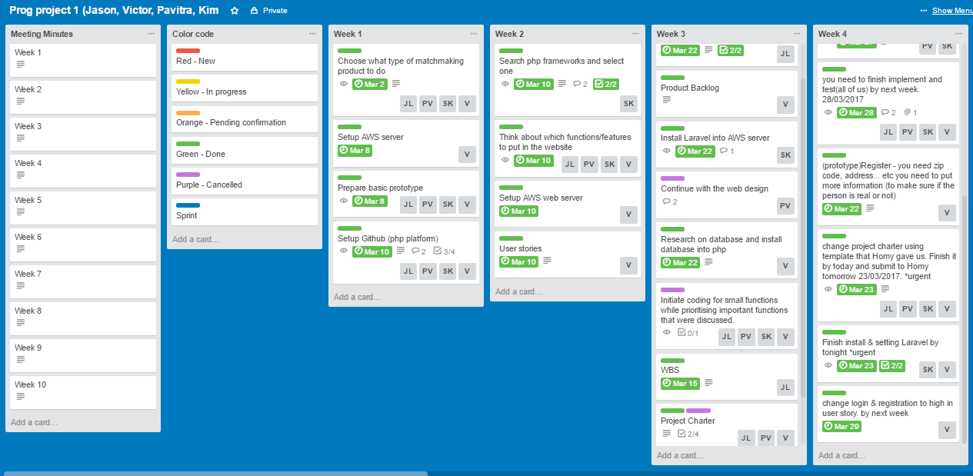

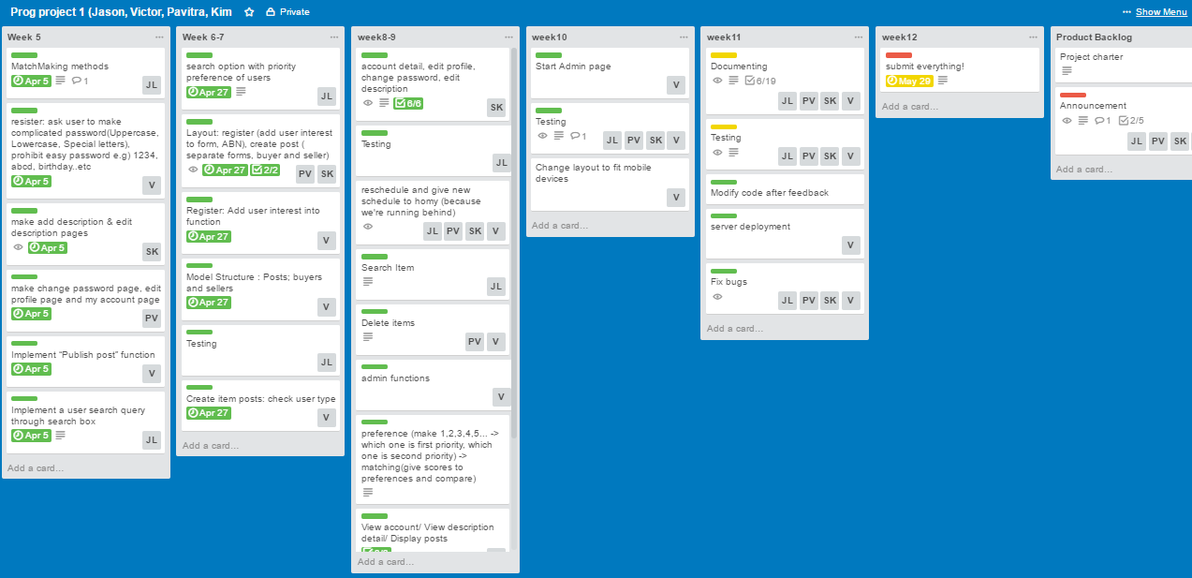

We used Trello as a tool for managing the project. We have structured Trello in Sprints according to the Scrum methodology, and grouped the sprints into columns named in a way to make it easier to track the progress of each sprint by every week.

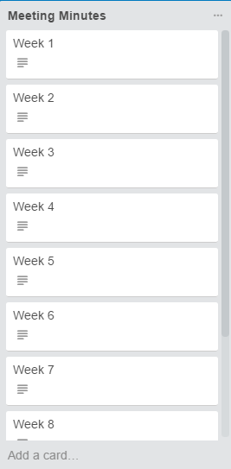

We made “Meeting Minutes” column which contains every week meeting minutes document file google drive url link.

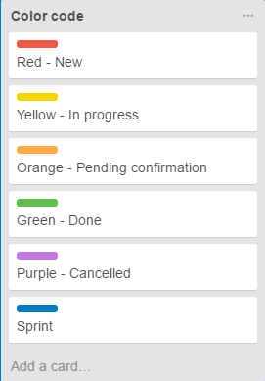

We made a “Color code” column and checked the weekly tasks progress by different color labels.

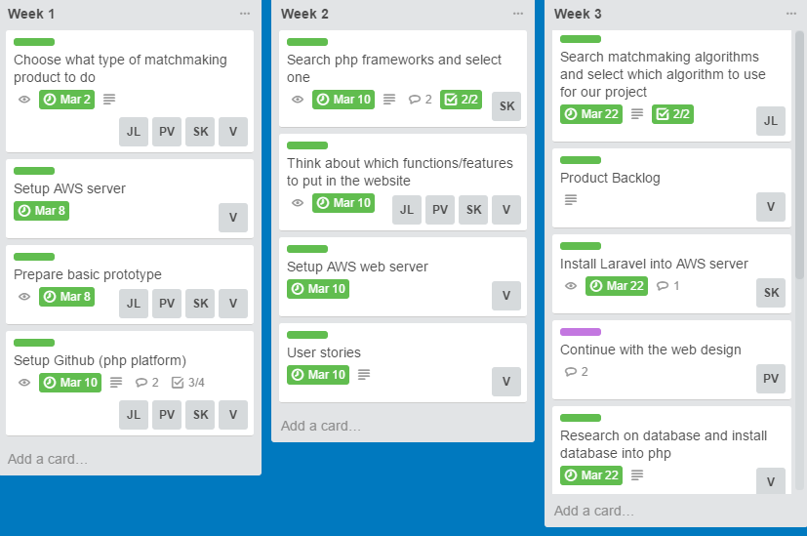

We made "Week (1-12)" columns which contains weekly tasks and we grouped sprints by week. We have put the person who is aimed for their tasks and due date for each task. We checked all progresses by different color codes.

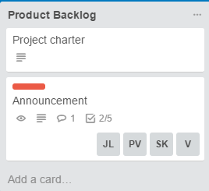

We made “Product Backlog” column and we created a list of product features by product requirements. This column has been changed by every week group meeting or every week meeting with supervisor.